Dimensional Aspect Based Sentiment Analysis

Submitted for

Foundations of AI Programming using Python ABAI1010L

Submitted by:
Sakshi Bohra
(A25ARIU0062)

Submitted to
DR. SHAKSHI SHARMA

July-Dec 2025
SCHOOL OF ARTIFICIAL INTELLIGENCE


  - Index
S. No. | Content | Page No.
1 | Abstract | 1
2 | Introduction | 1
3 | Related Work | 2
4 | Methodology | 2
5 | Hardware/Software Required | 2
6 | Experimental Results | 3
7 | Conclusions | 6
8 | Future Scope | 6
9 | GitHub Link of the Complete Project | 7

Abstract

Aspect-Based Sentiment Analysis (ABSA) is an advanced Natural Language Processing technique that identifies sentiment related to specific aspects within textual data. Unlike traditional sentiment analysis, which provides only an overall sentiment, ABSA offers a more detailed understanding by analyzing sentiments for individual aspects such as quality, price, and service.
This project focuses on developing a Python-based system that extracts aspects from customer reviews and determines their corresponding sentiment using machine learning and NLP techniques. The system utilizes publicly available datasets and libraries such as Transformers and PyTorch to process and analyze text data efficiently.
The proposed approach helps in gaining deeper insights from customer feedback, making it useful for businesses, product analysis, and decision-making systems.

  - Introduction
Sentiment analysis is a Natural Language Processing (NLP) technique used to determine the emotional tone behind textual data. Traditional sentiment analysis provides only an overall sentiment of a sentence or review, which may not capture opinions about specific features or aspects.
Aspect-Based Sentiment Analysis (ABSA) improves this by identifying sentiments related to individual aspects such as quality, price, service, etc. This project aims to build a system that extracts aspects from customer reviews and determines their corresponding sentiments using Python and machine learning techniques.

  - Related Work
Several research studies and applications have been developed in the field of sentiment analysis. Traditional methods focused on classifying overall sentiment using machine learning algorithms such as Naive Bayes and Support Vector Machines. However, these approaches lacked fine-grained analysis. Recent advancements use deep learning and transformer-based models like BERT for more accurate results. The SemEval ABSA dataset has been widely used as a benchmark for evaluating aspect-based sentiment analysis systems. This project builds upon these approaches to provide aspect-level sentiment classification using modern NLP techniques.

  - Methodology
The project follows a structured approach:
- Data Collection:
Use SemEval dataset containing labeled customer reviews.
- Data Preprocessing:
Clean text by removing stop words, punctuation, and performing tokenization.
- Aspect Extraction:
Identify key aspects (e.g., food, service, price) from the text.
- Sentiment Analysis:
Apply NLP models (Transformers) to classify sentiment for each aspect.
- Result Generation:
Display aspect-wise sentiment output.

  - Hardware/Software Required
Hardware:
- Laptop
Software:
- Python 3.x
- VS Code
- Libraries:
  - Transformers
  - Torch
  - Pandas
  - Streamlit

  - Experimental Results
The model was tested on sample customer reviews. It successfully identified different aspects and classified their sentiments accurately.
Example:
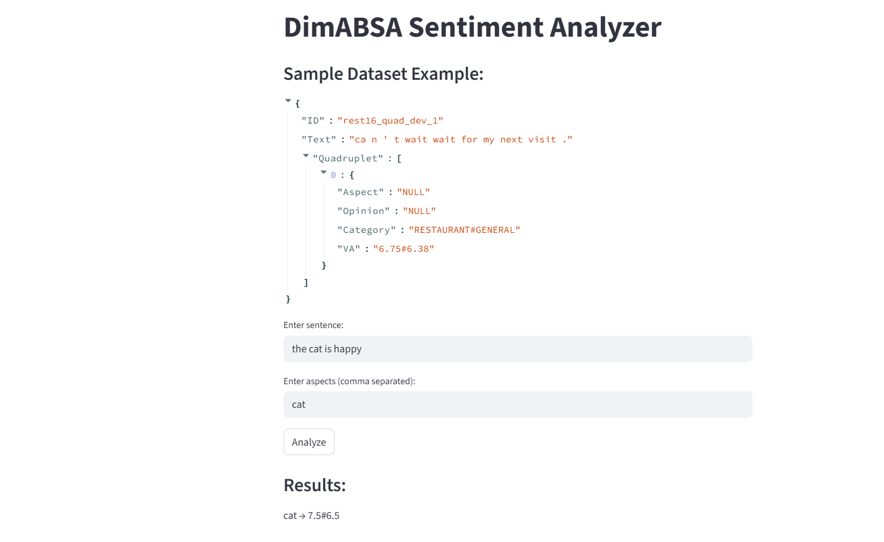
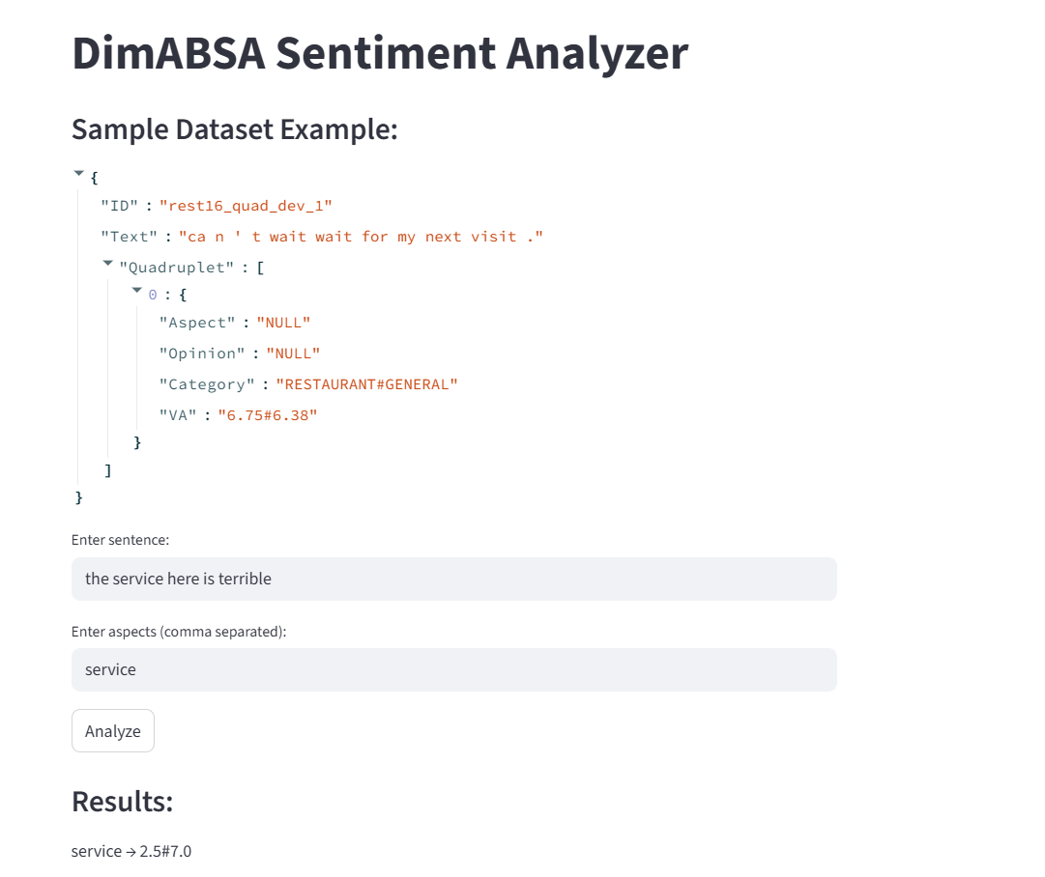
Test Case 1
Input:
Sentence: the cat is happy
Aspect: cat
Output:
cat → 7.5#6.5
Observation:
- The system identified the aspect “cat”
- High valence score indicates positive sentiment

Test Case 2
Input:
Sentence: the service here is terrible
Aspect: service
Output:
service → 2.5#7.0
Observation:
- The system identified the aspect “service”
- Low valence score indicates negative sentiment
- Higher arousal shows stronger emotional intensity

Final Observation
The results show that the system can:
- Analyze sentiment for specific aspects
- Provide detailed emotional scores (valence and arousal)
- Distinguish between positive and negative sentiments effectively
This proves that Aspect-Based Sentiment Analysis gives more detailed and useful results than traditional sentiment analysis.

  - Conclusions
This project demonstrates the effectiveness of Aspect-Based Sentiment Analysis in extracting detailed insights from textual data. By identifying sentiments for individual aspects, the system provides more meaningful information than overall sentiment classification. The use of Python and NLP libraries makes the system efficient and easy to implement.

  - Future Scope
- Improve accuracy using advanced deep learning models
- Add multilingual support
- Deploy as a web application using Flask
- Integrate real-time data from social media
- Enhance aspect extraction techniques

  - GitHub Link
https://github.com/bohrasakshi79-ux/dimabsa-project.git

